Equilateral Acute Triangle
# Source: AI Source: Provided by: [Data Path: Persons Table -> ID Column: 1, Name_En Column: Motasem Essam] -> From: [ChatGPT] on [7/25/2026]
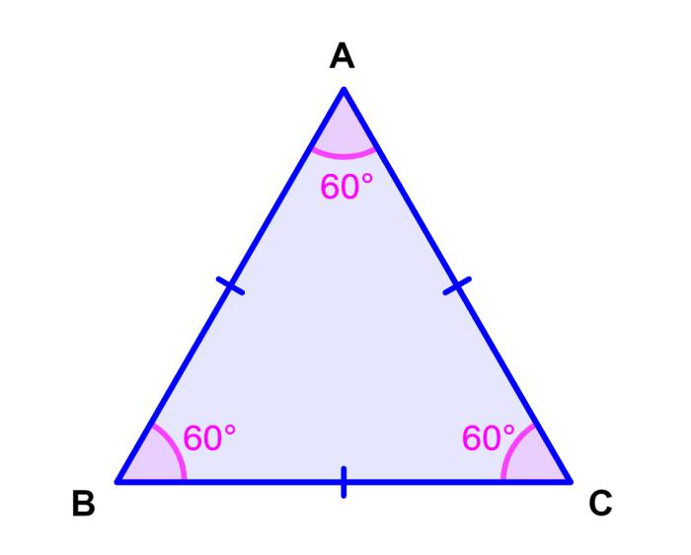
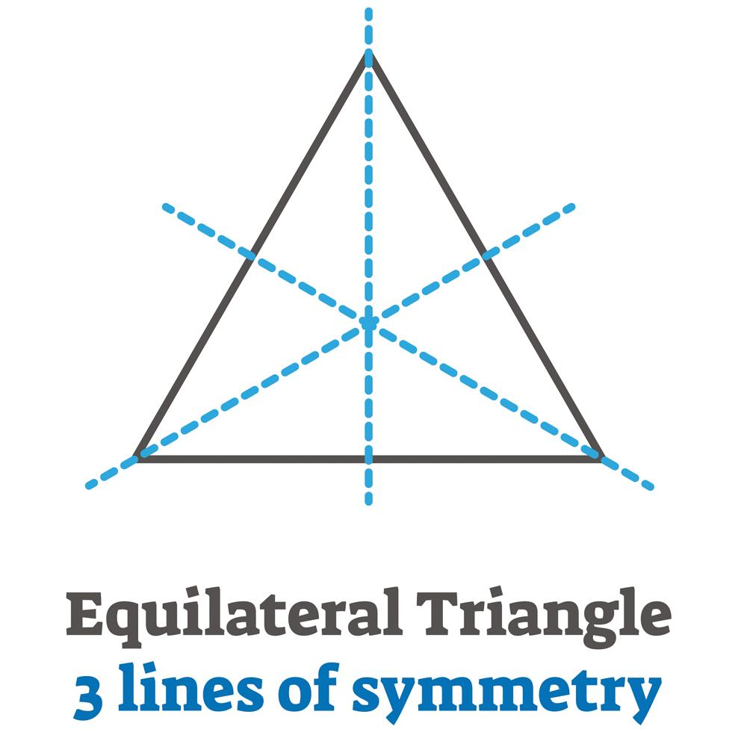
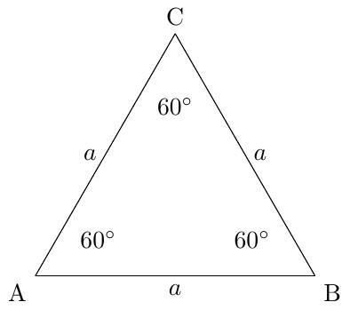
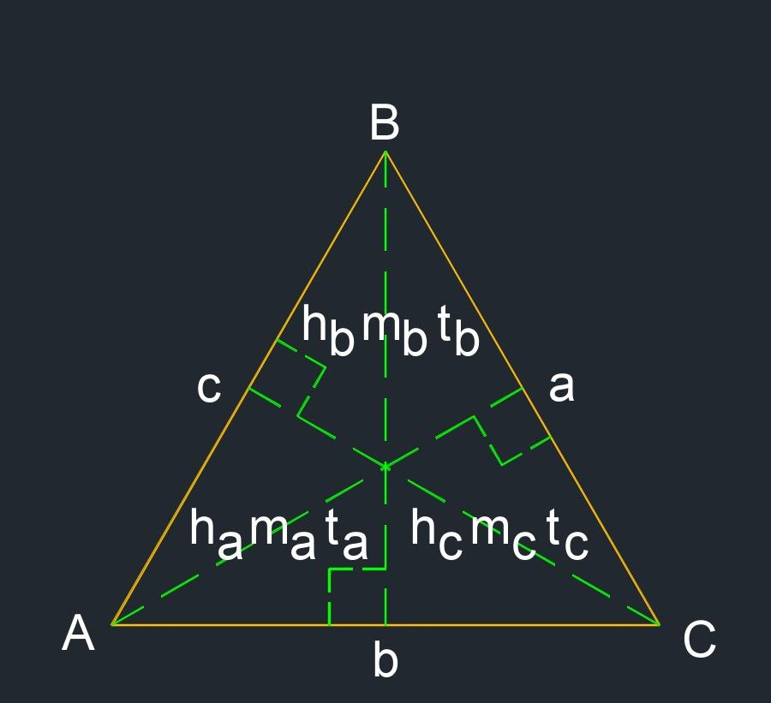

Definition
# Source: AI Source: Provided by: [Data Path: Persons Table -> ID Column: 1, Name_En Column: Motasem Essam] -> From: [ChatGPT] on [7/25/2026]
An Equilateral Acute Triangle is a triangle that is classified simultaneously:
- By sides: Equilateral — all three sides are equal.
- By angles: Acute — all three angles are less than ${90}^{∘}$.
For triangle $ABC$:
$$\boxed{AB=BC=CA}$$
and:
$$\boxed{∠A=∠B=∠C={60}^{∘}}$$
Since:
$${60}^{∘}<{90}^{∘}$$
every equilateral triangle is necessarily an acute triangle.

Classification
# Source: AI Source: Provided by: [Data Path: Persons Table -> ID Column: 1, Name_En Column: Motasem Essam] -> From: [ChatGPT] on [7/25/2026]
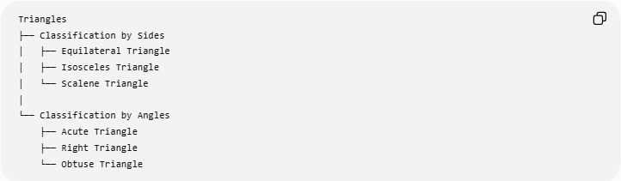
Triangles
├── Classification by Sides
│ ├── Equilateral Triangle
│ ├── Isosceles Triangle
│ └── Scalene Triangle
│
└── Classification by Angles
├── Acute Triangle
├── Right Triangle
└── Obtuse Triangle
The intersection of these two classifications gives:
Classification by Sides and Angles
└── Equilateral Acute Triangle
More specifically:
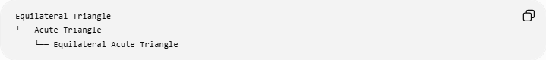
Equilateral Triangle
└── Acute Triangle
└── Equilateral Acute Triangle
Note: "Equilateral Acute Triangle" is a combined classification rather than a fundamentally new type of triangle. Every equilateral triangle is automatically acute.

Fundamental Properties

1. Three Equal Sides
# Source: AI Source: Provided by: [Data Path: Persons Table -> ID Column: 1, Name_En Column: Motasem Essam] -> From: [ChatGPT] on [7/25/2026]
$$\boxed{AB=BC=CA=a}$$
where $a$represents the common side length.

2. Three Equal Angles
# Source: AI Source: Provided by: [Data Path: Persons Table -> ID Column: 1, Name_En Column: Motasem Essam] -> From: [ChatGPT] on [7/25/2026]
$$\boxed{∠A=∠B=∠C={60}^{∘}}$$

3. All Angles Are Acute
# Source: AI Source: Provided by: [Data Path: Persons Table -> ID Column: 1, Name_En Column: Motasem Essam] -> From: [ChatGPT] on [7/25/2026]
Because:
$$\boxed{{60}^{∘}<{90}^{∘}}$$
the triangle satisfies the definition of an acute triangle.

4. Angle Sum
# Source: AI Source: Provided by: [Data Path: Persons Table -> ID Column: 1, Name_En Column: Motasem Essam] -> From: [ChatGPT] on [7/25/2026]
$$\boxed{{60}^{∘}+{60}^{∘}+{60}^{∘}={180}^{∘}}$$

Symmetry
# Source: AI Source: Provided by: [Data Path: Persons Table -> ID Column: 1, Name_En Column: Motasem Essam] -> From: [ChatGPT] on [7/25/2026]
An equilateral acute triangle has three lines of reflection symmetry.
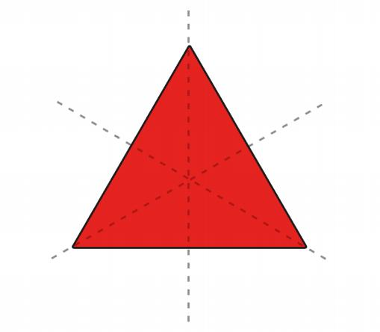
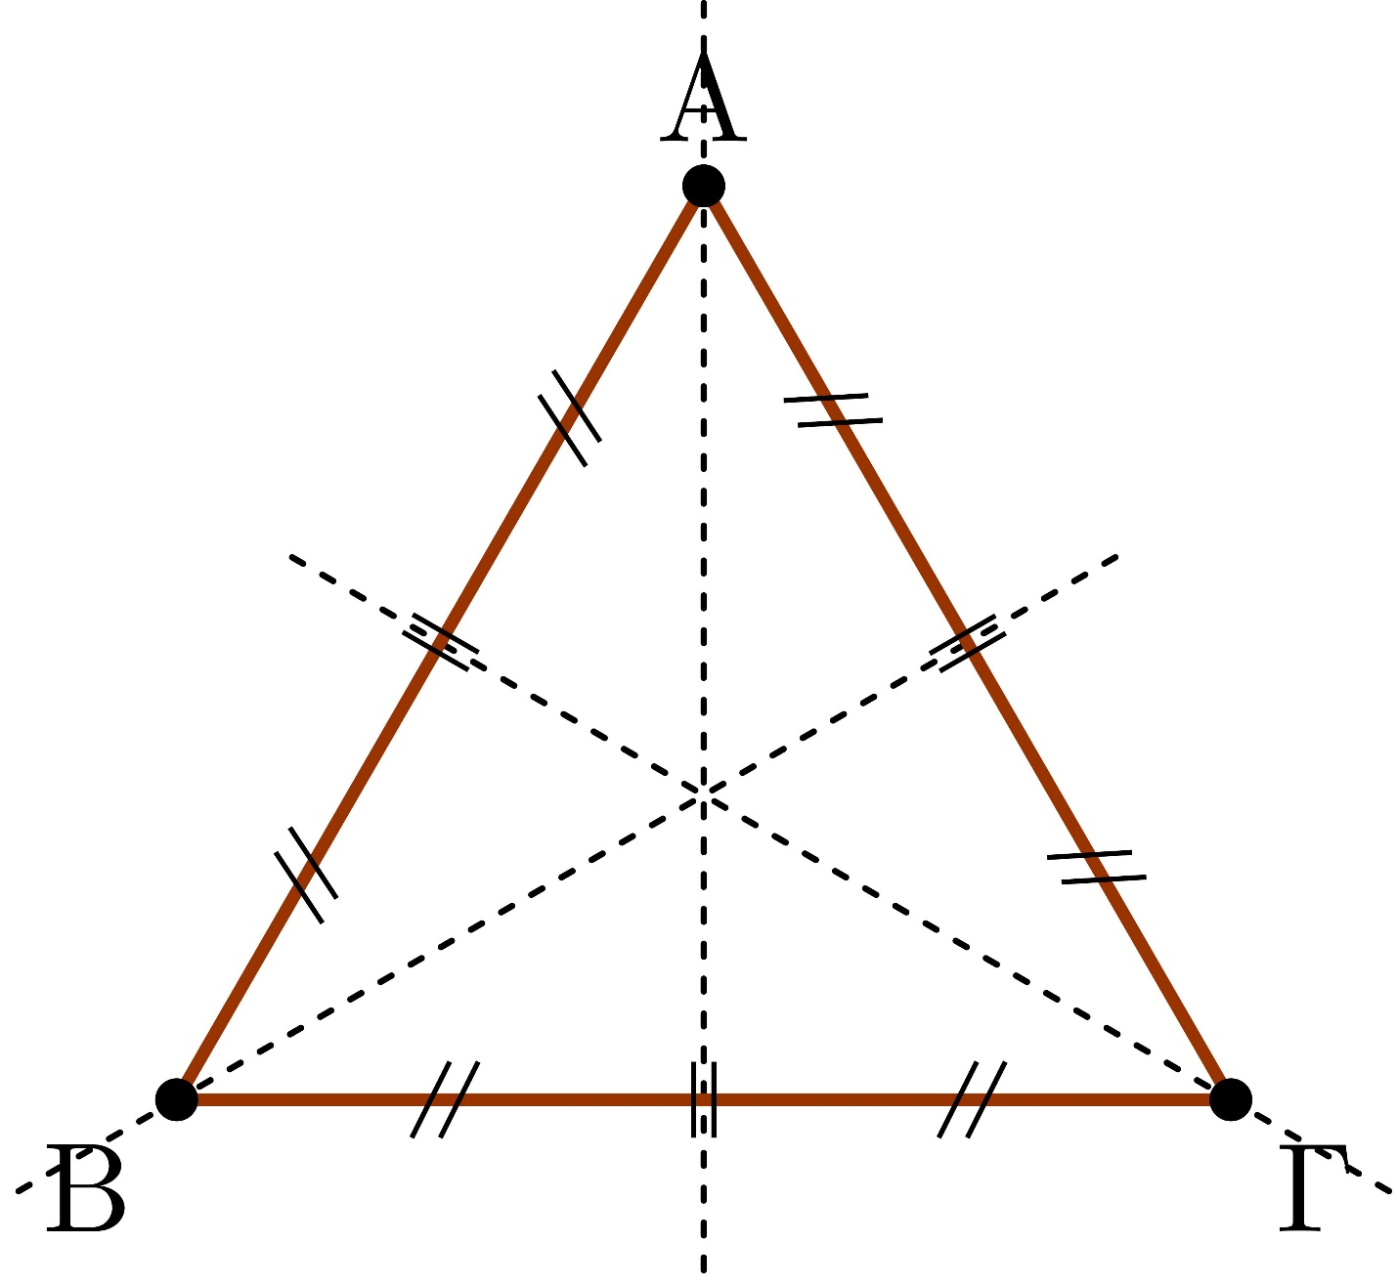
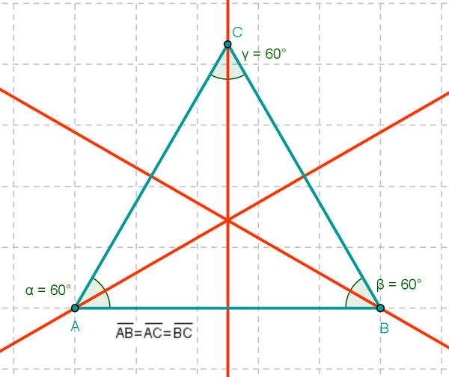
Each symmetry axis passes through:
- A vertex
- The midpoint of the opposite side
- The center of the triangle
Therefore, each symmetry axis is simultaneously a:
$$\boxed{\text{Median}} \\ \boxed{\text{Altitude}} \\ \boxed{\text{Angle Bisector}} \\ \boxed{\text{Perpendicular Bisector}}$$

Triangle Centers
# Source: AI Source: Provided by: [Data Path: Persons Table -> ID Column: 1, Name_En Column: Motasem Essam] -> From: [ChatGPT] on [7/25/2026]
The most important centers of an equilateral triangle all coincide.
$$\boxed{G=I=O=H}$$
where:
- $G$= centroid
- $I$= incenter
- $O$= circumcenter
- $H$= orthocenter
Thus, there is a single common center.
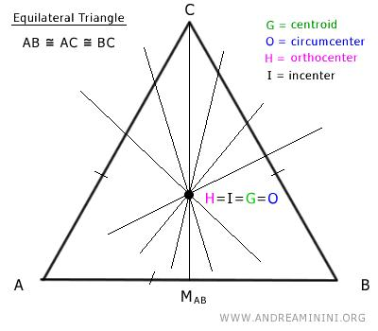
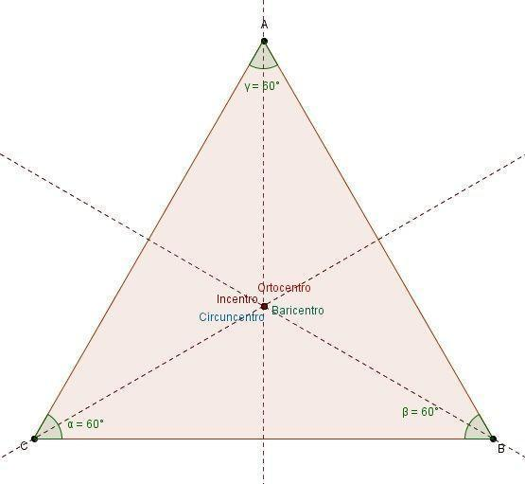
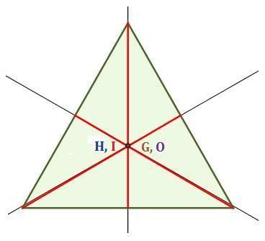

Altitude
# Source: AI Source: Provided by: [Data Path: Persons Table -> ID Column: 1, Name_En Column: Motasem Essam] -> From: [ChatGPT] on [7/25/2026]
For an equilateral triangle with side length $a$, the altitude is:
$$\boxed{h=\frac{\sqrt{3}}{2}a}$$
The altitude divides the equilateral triangle into two ${30}^{∘}-{60}^{∘}-{90}^{∘}$right triangles.
Therefore:
$$\boxed{\frac{a}{2}:\frac{\sqrt{3}}{2}a:a=1:\sqrt{3}:2}$$

Area
# Source: AI Source: Provided by: [Data Path: Persons Table -> ID Column: 1, Name_En Column: Motasem Essam] -> From: [ChatGPT] on [7/25/2026]
The area is:
$$\boxed{A=\frac{\sqrt{3}}{4}a^{2}}$$
This follows from:
$$A=\frac{1}{2}ah$$
and:
$$h=\frac{\sqrt{3}}{2}a$$
so:
$$A=\frac{1}{2}a\left(\frac{\sqrt{3}}{2}a\right) \\ \boxed{A=\frac{\sqrt{3}}{4}a^{2}}$$

Perimeter
# Source: AI Source: Provided by: [Data Path: Persons Table -> ID Column: 1, Name_En Column: Motasem Essam] -> From: [ChatGPT] on [7/25/2026]
Since all three sides have length $a$:
$$\boxed{P=3a}$$

Inradius
# Source: AI Source: Provided by: [Data Path: Persons Table -> ID Column: 1, Name_En Column: Motasem Essam] -> From: [ChatGPT] on [7/25/2026]
The distance from the common center to any side is the inradius:
$$\boxed{r=\frac{\sqrt{3}}{6}a}$$
The area also satisfies:
$$\boxed{A=rs}$$
where the semiperimeter is:
$$s=\frac{3a}{2}$$

Circumradius
# Source: AI Source: Provided by: [Data Path: Persons Table -> ID Column: 1, Name_En Column: Motasem Essam] -> From: [ChatGPT] on [7/25/2026]
The distance from the common center to any vertex is the circumradius:
$$\boxed{R=\frac{\sqrt{3}}{3}a}$$
The relationship between the circumradius and inradius is:
$$\boxed{R=2r}$$

Euler Line
# Source: AI Source: Provided by: [Data Path: Persons Table -> ID Column: 1, Name_En Column: Motasem Essam] -> From: [ChatGPT] on [7/25/2026]
In a general non-equilateral triangle, the centroid, circumcenter, and orthocenter form the Euler line.
For an equilateral triangle:
$$\boxed{G=O=H}$$
Therefore, the three points collapse into a single point.
The usual Euler-line relationship becomes degenerate because there are not three distinct centers to determine a unique line.

Medians, Altitudes, and Angle Bisectors
# Source: AI Source: Provided by: [Data Path: Persons Table -> ID Column: 1, Name_En Column: Motasem Essam] -> From: [ChatGPT] on [7/25/2026]
For an equilateral triangle, each of the following segments from a vertex to the opposite side is the same geometric segment:
$$\boxed{\text{Median}=\text{Altitude}=\text{Angle Bisector}}$$
It is also the perpendicular bisector of the opposite side.
Thus, there are three segments that simultaneously have all four roles.

Rotational Symmetry
# Source: AI Source: Provided by: [Data Path: Persons Table -> ID Column: 1, Name_En Column: Motasem Essam] -> From: [ChatGPT] on [7/25/2026]
An equilateral triangle has rotational symmetry of order $3$.
It maps onto itself after rotations of:
$$\boxed{{120}^{∘}, {240}^{∘}, {360}^{∘}}$$
The smallest positive angle of rotational symmetry is:
$$\boxed{{120}^{∘}}$$

Exterior Angles
# Source: AI Source: Provided by: [Data Path: Persons Table -> ID Column: 1, Name_En Column: Motasem Essam] -> From: [ChatGPT] on [7/25/2026]
Each exterior angle is:
$$\boxed{{120}^{∘}}$$
because:
$${180}^{∘}-{60}^{∘}={120}^{∘}$$
The three exterior angles sum to:
$$\boxed{{360}^{∘}}$$

Pythagorean Relationship
# Source: AI Source: Provided by: [Data Path: Persons Table -> ID Column: 1, Name_En Column: Motasem Essam] -> From: [ChatGPT] on [7/25/2026]
An altitude divides the equilateral triangle into two ${30}^{∘}-{60}^{∘}-{90}^{∘}$right triangles.
For one of these right triangles:
$${\left(\frac{a}{2}\right)}^{2}+{\left(\frac{\sqrt{3}}{2}a\right)}^{2}=a^{2}$$
which confirms the relationship between the half-side, altitude, and original side.

Example
# Source: AI Source: Provided by: [Data Path: Persons Table -> ID Column: 1, Name_En Column: Motasem Essam] -> From: [ChatGPT] on [7/25/2026]
Suppose an equilateral acute triangle has:
$$a=6$$
Side lengths
$$\boxed{AB=BC=CA=6}$$
Angles
$$\boxed{∠A=∠B=∠C={60}^{∘}}$$
Height
$$h=\frac{\sqrt{3}}{2}\left(6\right) \\ \boxed{h=3\sqrt{3}}$$
Area
$$A=\frac{\sqrt{3}}{4}{\left(6\right)}^{2} \\ \boxed{A=9\sqrt{3}}$$
Perimeter
$$P=3\left(6\right) \\ \boxed{P=18}$$
Inradius
$$r=\frac{\sqrt{3}}{6}\left(6\right) \\ \boxed{r=\sqrt{3}}$$
Circumradius
$$R=\frac{\sqrt{3}}{3}\left(6\right) \\ \boxed{R=2\sqrt{3}}$$
and:
$$R=2r$$

Relationship to Other Triangle Classifications
# Source: AI Source: Provided by: [Data Path: Persons Table -> ID Column: 1, Name_En Column: Motasem Essam] -> From: [ChatGPT] on [7/25/2026]
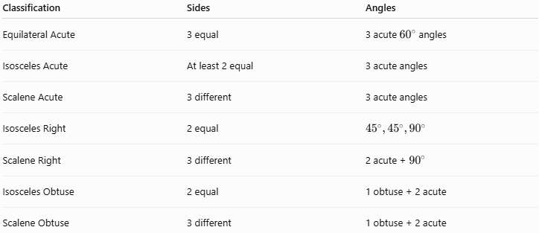
Classification | Sides | Angles
Equilateral Acute | 3 equal | 3 acute ${60}^{∘}$angles
Isosceles Acute | At least 2 equal | 3 acute angles
Scalene Acute | 3 different | 3 acute angles
Isosceles Right | 2 equal | $${45}^{∘},{45}^{∘},{90}^{∘}$$
Scalene Right | 3 different | 2 acute + ${90}^{∘}$
Isosceles Obtuse | 2 equal | 1 obtuse + 2 acute
Scalene Obtuse | 3 different | 1 obtuse + 2 acute
An equilateral right or equilateral obtuse triangle does not exist.

Key Points
# Source: AI Source: Provided by: [Data Path: Persons Table -> ID Column: 1, Name_En Column: Motasem Essam] -> From: [ChatGPT] on [7/25/2026]
- An Equilateral Acute Triangle has three equal sides and three acute angles.
- Every angle is exactly:
$$\boxed{{60}^{∘}}$$
- Every equilateral triangle is automatically acute.
- Its three sides are equal:
$$\boxed{AB=BC=CA}$$
- Its altitude is:
$$\boxed{h=\frac{\sqrt{3}}{2}a}$$
- Its area is:
$$\boxed{A=\frac{\sqrt{3}}{4}a^{2}}$$
- Its perimeter is:
$$\boxed{P=3a}$$
- Its inradius is:
$$\boxed{r=\frac{\sqrt{3}}{6}a}$$
- Its circumradius is:
$$\boxed{R=\frac{\sqrt{3}}{3}a}$$
- The four principal triangle centers coincide:
$$\boxed{G=I=O=H}$$
- Every median is also an altitude, angle bisector, and perpendicular bisector.
- It has three reflection-symmetry axes and rotational symmetry of order $3$.

Conclusion
# Source: AI Source: Provided by: [Data Path: Persons Table -> ID Column: 1, Name_En Column: Motasem Essam] -> From: [ChatGPT] on [7/25/2026]
An Equilateral Acute Triangle is the combined classification obtained when a triangle is equilateral by its sides and acute by its angles. It has three equal sides, three equal ${60}^{∘}$angles, three symmetry axes, and a single common location for its centroid, incenter, circumcenter, and orthocenter. It is therefore one of the most symmetric and geometrically regular triangle configurations.

